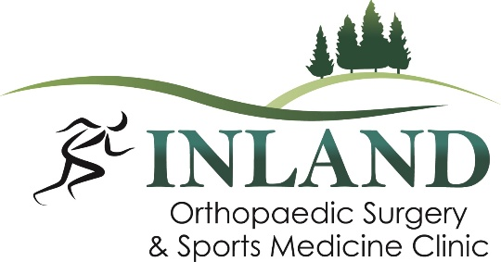

Position Available: Patient Service Representative
Type: Full-Time
Salary: Competitive wage and benefit package, DOE
Start Date: Available immediately
Schedule: Monday – Friday
Location: Moscow, ID/Pullman, WA

Inland Orthopaedic Surgery and Sports Medicine Clinic, PLLC is proud to be the Palouse’s most established orthopaedic practice delivering quality orthopaedic and sports medicine care. Our physicians and team members provide exceptional patient-centered care giving an overall experience for patients of all ages. We are seeking an upbeat, positive and reliable Patient Service Representative that would like to be part of our team. This is a fast-paced medical clinic and we are looking for a friendly person to be the first point of contact for our patients. This position is available immediately and will work in both of our locations when needed. Competitive wage & benefit package, and consistent hours. Applications will continue to be accepted until position has been filled.
Preferred qualifications include, but are not limited to:
- One year medical office experience preferred.
- One year customer service experience preferred.
- Strong organization and multitasking skills.
- Experience with an EMR, preferably EPIC.
- Knowledge of medical terminology.
- Ability to perform detailed work in a timely manner with accuracy and thoroughness.
- Excellent communication skills and ability to work in a team environment and cooperatively with customers.
- Experience with Microsoft Office.
- Professional demeanor and pleasant, friendly tone of voice.

Primary job responsibilities include, but are not limited to
- Ability to apply critical thinking and problem solving skills
- Proficient in Microsoft Suite (Outlook, Word, Excel, PowerPoint)
- Skilled in Adobe and Canva
- Comfortable with both Apple and Microsoft products
- Experience with an electronic medical records system, preferably Epic
- Skills in assisting with special projects by coordinating resources and tracking progress
- Excellent phone etiquette and ability to communicate effectively resulting in enhanced patient education & fostering greater patient understanding and satisfaction with patients
- Ability to multi-task
- Ability to maintain composure in stressful situations
- Consistency and timeliness in attendance

Benefits:
- 401(k) with Employer Contributions
- Medical/Vision, Dental
- Paid Time Off
- Life insurance
- Paid Holidays
Work Location: In person, not eligible for remote work.

Applicants must submit both resume and cover letter. Your cover letter must specify why you would be the ideal candidate to join our Inland Orthopaedic Surgery & Sports Medicine team. We look forward to hearing about your desire to join our team and contribute to the success of our practice.

Application can be found at: https://www.inlandortho.net/careers

Email for resume, application and cover letter: sbull@inlandortho.net

Inland Orthopaedic Surgery & Sports Medicine, LLC is an equal employment opportunity employer. We adhere to a policy of making employment decisions without regard to race, color, religion, sex, sexual orientation, national origin, citizenship, age or disability. We assure you that your opportunity for employment with Inland Orthopaedic Surgery & Sports Medicine depends solely on your qualifications.

Inland Orthopaedic Surgery is a drug-free, alcohol-free, and smoke-free workplace. If offered employment, passage of background screen and pre-employment drug screen is required.

