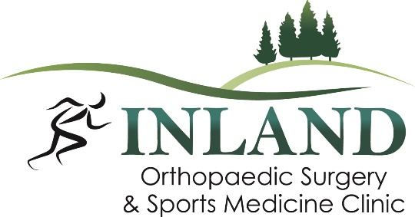

Position Available: Certified Athletic Trainer
Start Date: As soon as possible
Schedule: Monday – Friday
Location: Moscow, ID and Pullman, WA

Inland Orthopaedic Surgery and Sports Medicine Clinic, PLLC is proud to be the Palouse’s most established orthopaedic practice delivering quality orthopaedic and sports medicine care. Our physicians and team members provide exceptional patient-centered care for a better overall experience for patients of all ages. We are seeking upbeat, reliable Certified Athletic Trainers who are looking for a long-term career in the orthopaedic healthcare field. The ATC would work closely with our provider/physician team performing various clinical tasks. This position is available now in both our locations, Moscow, ID and Pullman, WA. Competitive wage and benefit package including growth opportunities offered. Applications will continue to be accepted until position has been filled.

The Ideal Candidate For This Position Will Have:
- Effective interpersonal skills to communicate both in person and in writing
- Strong work ethic and ability to prioritize multiple tasks and follow through in a timely manner
- Excellent customer service skills
- Ability to work independently and as an effective team member
- Have initiative to ask questions, make proposals, and effectively problem solve
- Ability to clearly organize and maintain files and documents, both digital and printed
- Demonstrate the ability and willingness to learn unfamiliar tasks and equipment operation within the scope of position
- To accept change in a positive and professional manner and to lead others in the same

Skills/Knowledge/Abilities
- Applied Knowledge: Athletic trainers must have knowledge about a large range of medical problems. Assessment and evaluation skills and working with other healthcare professionals will be needed.
- Decision-Making Skills: Quick thinking by athletic trainers are vital to patient health.
- Attention to Detail: Athletic trainers should take notes on how people are recovering and how to best keep them healing.
- Interpersonal Skills: Athletic trainers work with people in stressful situations. Keeping a clear head and calm demeanor when talking to patients, medical professionals, staff and families will be an asset.
- Must have strong oral communication skills (reading, writing, speaking and comprehension).
- Must have the ability to organize, prioritize and perform multiple tasks with little or no supervision.
- Consistency and timeliness in attendance

Specific Duties & Responsibilities
- Rooming patients and taking vitals, patient history, initial evaluation and documentation.
- Removing sutures and preparing injections.
- Prepares for and assists physician within in-office procedures.
- Verifying images are available and uploaded to EMR.
- Assisting with cast application and removal.
- Responsible for brace and crutch fitting and product education.
- Triage patient messages, calling in prescription refills, taking/making phone calls and questions appropriately, whether it is resolving issue within the scope of practice or utilizing the physician.
- Design and educate patients on home exercise protocols per the physician’s request.
- Responsible for patient setup and education of in office procedures.
- Maintaining efficient patient flow by cleaning exam rooms between patients
- Preparing physical therapy orders and scheduling therapy
- Tracking medical supply inventory and ordering and stocking medical supply room and exam rooms
- Outreach program development when needed
- Liaison between patient, physician or other clinical/non-clinical staff.
- Uploads supporting documentation and authorization information into the EMR consistent with electronic record policy
- Other duties as assigned within scope of licensure
- Completes special projects as assigned.

Job Requirements
- Bachelors or Masters of Science degree, in Athletic Training
- Current BLS and State of Idaho Training License. NATA certified preferred.
- Preference of two years experience, however, will train the right person with minimal or no experience.

Inland Orthopaedic Surgery & Sports Medicine, LLC is an equal employment opportunity employer. We adhere to a policy of making employment decisions without regard to race, color, religion, sex, sexual orientation, national origin, citizenship, age or disability. We assure you that your opportunity for employment with Inland Orthopaedic Surgery depends solely on your qualifications

Inland Orthopaedic Surgery is a drug-free, alcohol-free, and smoke-free workplace. If offered employment, passage of background screen and pre-employment drug screen is required.

